
RAMAIAH
Institute of Technology
USN | 1 | M | S

(Autonomous Institute, Affiliated to VTU)
(Approved by AICTE, New Delhi & Govt. of Karnataka) Accredited by NBA & NAAC with ‘A’ Grade

MAKEUP EXAMINATIONS – FEBRUARY 2020
Program | : | B.E.: Electrical and Electronics Engineering | Semester | : | VII
Course Name | : | Digital Image Processing | Max. Marks | : | 100
Course Code | : | EEE24 | Duration | : | 3 Hrs

Instructions to the Candidates:
- Answer one full question from each unit.

 |  | UNIT- I
1. | a) | Mention the components of the image function f(x,y). Also elaborate the role of the following steps in digital image processing system: Image acquisition, image enhancement, image segmentation and image recognition. | CO1 | (08)
 | b) | Discuss the elements of visual perception. | CO1 | (06)
 | c) | Consider the two image subset s1 and s2 shown in the following figure.1(c). For V={1}, Find if two subsets s1 and s2 are (i) 4-adjacent (ii) 8-adjacent (iii) m-adjacent.  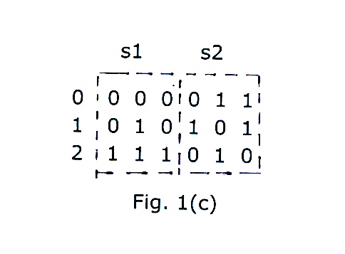 | CO1 | (06)
2. | a) | Define and interpret with suitable example, sampling and Quantization. | CO1 | (10)
 | b) | With suitable illustrations, discuss the neighbors of a pixel and the distance measures as applied to the basic relationships between the pixels. | CO1 | (08)
 | c) | What is the storage space required for 456*518, 120-gray level image? | CO1 | (02)
 |  | UNIT- II
3. | a) | What is image enhancement? Discuss the point processing techniques of image enhancement: (i) Contrast Stretching (ii) Gray level Slicing (iii) Histogram equalization. | CO2 | (12)
 | b) | With the principle of Pseudo colour image processing, explain the intensity slicing technique of the same. | CO2 | (08)
4. | a) | Analyse i) Image negative ii) Histogram sliding iii) Histogram operation on the image segment 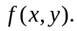  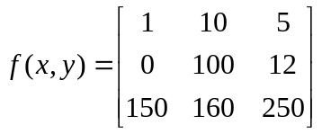 | CO2 | (08)
 | b) | Discuss on log transformation with respect to | CO2 | (04)
 | c) | Analyse power law transform operation on the segment | CO2 | (08)
 |  | UNIT- III
5. | a) | Write the steps involved in frequency domain smoothing filtering with the help of block diagram. | CO3 | (06)
 | b) | Apply spatial domain filtering for the pixel (4,4) using 3 X 3 mask . andrepeat for 5 X 5 mask except laplacian filter. | CO3 | (14)
  0 | 1 | 1 | 0 | 0 | 1 | 1 | 0
  0 | 1 | 2 | 3 | 3 | 2 | 1 | 0
  0 | 4 | 5 | 3 | 3 | 5 | 4 | 0
  0 | 1 | 2 | 7 | 7 | 2 | 1 | 0
  0 | 1 | 2 | 6 | 6 | 2 | 1 | 0
  0 | 4 | 5 | 3 | 3 | 5 | 4 | 0
  0 | 1 | 2 | 3 | 3 | 2 | 1 | 0
  0 | 1 | 1 | 0 | 0 | 1 | 1 | 0
6. | a) | With the help of block diagram, explain the Homomorphic filtering approach for image enhancement. What are the advantages of this filters. | CO3 | (10)
 | b) | Apply spatial domain filtering for the pixel value 120 using 3X 3 mask. | CO3 | (10)
  0 | 10 | 5 | 100
  5 | 95 | 150 | 20
  120 | 50 | 190 | 210
  175 | 210 | 255 | 110
 |  | UNIT- IV
7. | a) | Explain image segmentation techniques in details . | CO4 | (10)
 | b) | Apply denoising using restoration method using 3X3 mask on the pixel value 12. | CO4 | (10)
  0 | 1 | 1 | 0 | 0 | 1 | 1 | 0
  0 | 1 | 12 | 3 | 3 | 2 | 1 | 0
  0 | 4 | 5 | 3 | 3 | 5 | 4 | 0
  0 | 1 | 2 | 7 | 7 | 2 | 1 | 0
  0 | 1 | 2 | 6 | 6 | 2 | 1 | 0
  0 | 4 | 5 | 3 | 3 | 5 | 4 | 0
  0 | 1 | 2 | 3 | 3 | 2 | 1 | 0
  0 | 1 | 1 | 0 | 0 | 1 | 1 | 0
8. | a) | Write in details threshold based segmentation. | CO4 | (10)
 | b) | For the given 8×8 image given below, implement image segmentation using region merging technique based on  Max{f(x,y)}-min{f(x,y)}≤ th, here threshold value i) th= 4 , ii) th=2. | CO4 | (10)
  0 | 1 | 1 | 0 | 0 | 1 | 1 | 0
  0 | 1 | 2 | 3 | 3 | 2 | 1 | 0
  0 | 4 | 5 | 3 | 3 | 5 | 4 | 0
  0 | 1 | 2 | 7 | 7 | 2 | 1 | 0
  0 | 1 | 2 | 6 | 6 | 2 | 1 | 0
  0 | 4 | 5 | 3 | 3 | 5 | 4 | 0
  0 | 1 | 2 | 3 | 3 | 2 | 1 | 0
  0 | 1 | 1 | 0 | 0 | 1 | 1 | 0
 |  | UNIT- V
9. | a) | U=ones(4,4); find forward and inverse hadmard transform. | CO5 | (10)
 | b) | For the input image u=ones(8,8), find the transformed image V using Haar transform. | CO5 | (10)
10. | a) | Given A=sqrt(1/2)*[1 1;1 -1] and u=[1 2; 3 4], find the transformed image V. Calculate Basis images. | CO5 | (06)
 | b) | Find the transform matrix & KL transform of u=[ 4 -2;-1 3]; | CO5 | (14)

****************

